

Dynamics 365 Customer Insights

Lab 4B Segments, Customer Cards, Activities, Enrichment

**Contents**

Module Introduction 2

Exercise 1 – Segmentation 4

Task 1 – Segment using Profiles: Customers from California 5

Task 2 – Segment using Measures: High Value Online Customers 6

Task 3 – Segment from scratch: Summer Promo 8

Task 4 – Review Segments 9

Task 5 – Apply Segment Insights 11

Task 6 – Segment Expansion 14

Optional – Suggested Segments 17

Exercise 2 – Customer Search 24

Task 1 – Configure the Search Columns and Filter Index 24

Task 2 – Search for a Customer Record 25

Exercise 3 – Setting up Activities 26

Task 1 – Add an activity for eCommerce Purchases 27

Task 2 – Add an activity for PoSPurchases 29

Task 3 – Add an activity for Website Reviews 31

Task 4 – Confirm the Activities 33

Exercise 4 – Enriching the Data 34

Task 1 – Adding Brand Affinity 34

Task 2 – Adding Interests Affinity 37

Task 3 – Review the Enriched Data 40

# Module Introduction

## Segmentation

You will create marketing segments to promote Contoso Coffee’s new Cold Brew Coffee offering as well as to identify customers with a higher-than-average online spend whom Contoso wish to target with their new subscription and connected coffee machine services.  
These segments will allow Contoso Coffee Marketing to deliver personalised, targeted marketing journeys for upcoming product launch.

## Customer Search and Cards

You will use the Customers section of Customer Insights to review the unified customer profiles. After defining the fields to be indexed you will search for customers and will review the information shown about each unified customer profile.

## Activities

Activities provide a way for you to track very specific “tasks” that people are performing.

## Data Enrichment

Enrich your customer profiles with brands and interest affinities with the help of Microsoft Graph or any third-party application.

## Objectives

* Generate Segments for use by Marketing
* Setup search and indexing for customers
* Configure Activities within Customer Insights
* Setup Data Enrichment

## Prerequisites

To complete the Customer Insights lab, you will need the following

* **Dynamics 365 Marketing** Instance or Trial
* Access to **Power Apps** or a Power Apps Trial
* Access to **Power Automate** or a Power Automate Trial
* Access to **Power BI** or a Power BI Trial
* **Microsoft Azure** Trial
* **Customer Insights** Trial

If you do not have access to the above, you can follow Lab 3 to get setup.

## Approximate Time to Complete – 90 mins

# Exercise 1 – Segmentation

Segments enable you to group your customers into cohorts based on demographic, transactional, or behavioural customer attributes. Using segmentation, you can achieve more targeted actions such as promotional campaigns, sales activities, or customer support actions to achieve desired business goals. You can define complex filters around the Customer Profile entity and its graph of related entities. Each segment, after processing, outputs a set of customer entity records that you can export and take actions upon.

Segments can be static (defined at the point you activate them) or Dynamic. If you create a Dynamic segment, customers will drop in and out of the segment as they meet or no longer meet the criteria you define.

Using Customer Insights, Segments can be exported to **Dynamics 365 Marketing** or several other business applications and used to execute a targeted Customer Journey. Segments can also be exported to .csv or accessed via API.

Customer Insights also provides insights over the created segments. Using **Segment insights**, you can find what differentiates two segments or what they have in common. **Segment overlap** shows which customers are common among the segments. **Segment differentiators** helps you find what differentiates a segment from the rest of your customers or the other segments. With both of these insights you can compare the segments against attributes and measures.

In this lab you will segment your unified customer profiles, to uncover cohorts of customers with similar attributes. There are two ways to create segments. First you can create them manually using the **New** -> **Blank Segment** button on the top left of the screen after clicking on **Segments** in the left-hand menu. However, there is a new way using one of the **Create from** options on that page. We will do it all the ways. At the end, we will review each segment and apply insights over them to discover additional information.

## Task 1 – Segment using Profiles: Customers from California

1. Let’s create a segment called **Customers from California** quickly using the profiles**.**
2. Click on **Segments** in the left menu
3. Click the **New** dropdown and select **Create From -> Profiles**

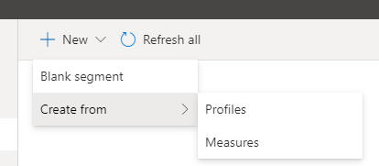

1. Select the **Field -> State** and **Value -> California**
2. Click **Review**
3. Name your segment **Customers From California** and set the output entity name to **CustomersFromCalifornia**

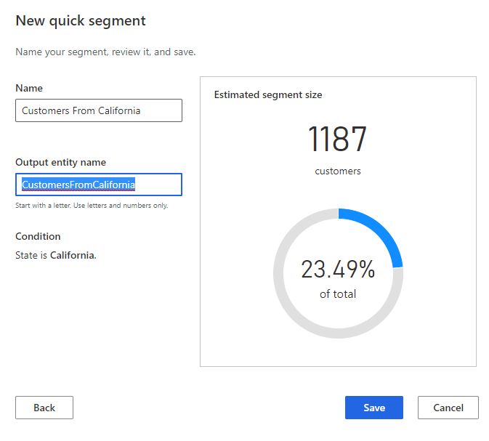

1. Click **Save**

## Task 2 – Segment using Measures: High Value Online Customers

Contoso Coffee Marketing wants to run a new promotion to convert customers to subscription model. Marketing have identified that they wish to target brew-at-home customers with a higher than average online purchase value to do so. We will create this segment using the Quick Create.

1. Click on **Segments** in the left menu
2. Click the **New** dropdown and select **Create From -> Measures**



1. Select the **Average Web Purchase ($)** attribute
2. Set the operator to **Greater Than**
3. Set the value to **138.** You should have a new quick segment screen like this:

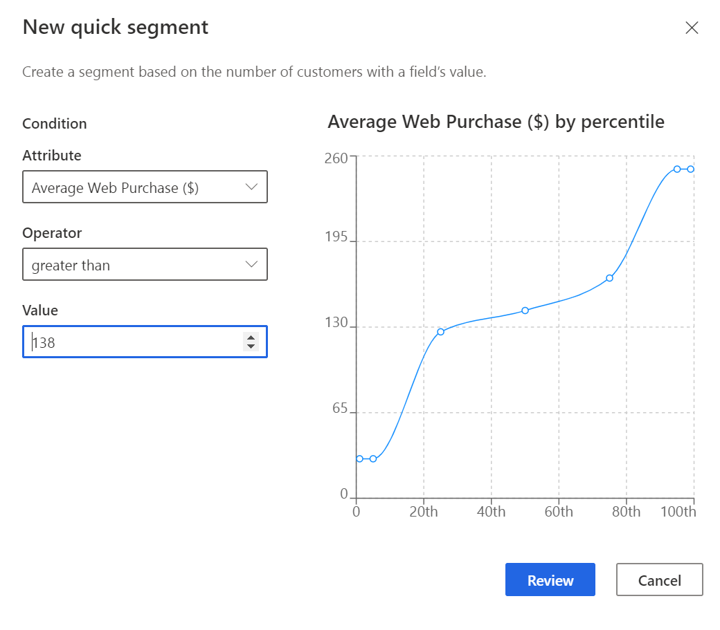

1. Click **Review**
2. Name your segment **High Value Online Customers** and set the output entity name to **HighValueOnlineCustomers**

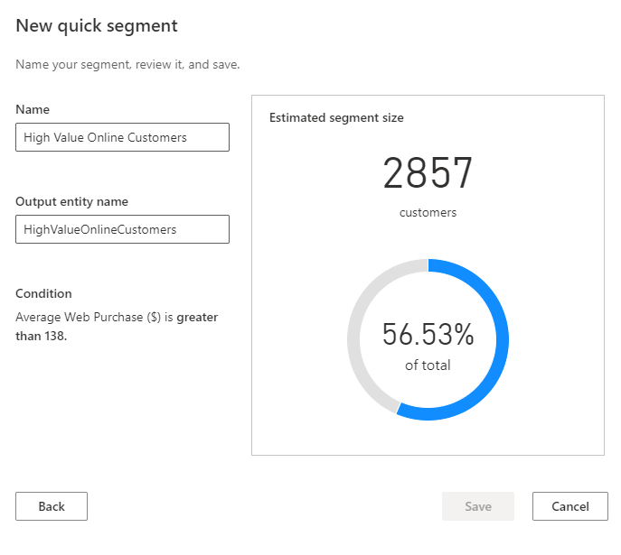

1. Click **Save**

## Task 3 – Segment from scratch: Summer Promo

Contoso Coffee Marketing want to run a new Summer Promotion targeting millennials with a higher than average in-store purchase with their newly launched Cold Brew Coffee. We will create this segment manually.

1. Click on **Segments** in the left menu and Click on **+ New** and select **Blank segment.**
2. Set Type to **Dynamic**, Name to **Summer Promotion**,Output entity name to **SummerPromo** and click **Next**
3. Select **Customer_Measure : Customer Insights** in the **Group 1: Define filter**
4. Set the fields to **Average Store Purchase ($)**, **greater than or equal to** and **113**

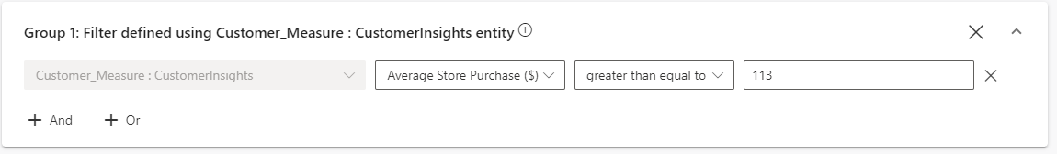  
**Note:** 113 is the average In-store purchase we calculated earlier.

1. Click **+** **AND** then add **Customer : CustomerInsights**, **DateOfBirth**, **greater than or equal to** **1/1/1981**
2. Click **+** **AND** then set to **DateOfBirth less than or equal to 12/31/1996**
3. Click **+ And** then select **All Records**

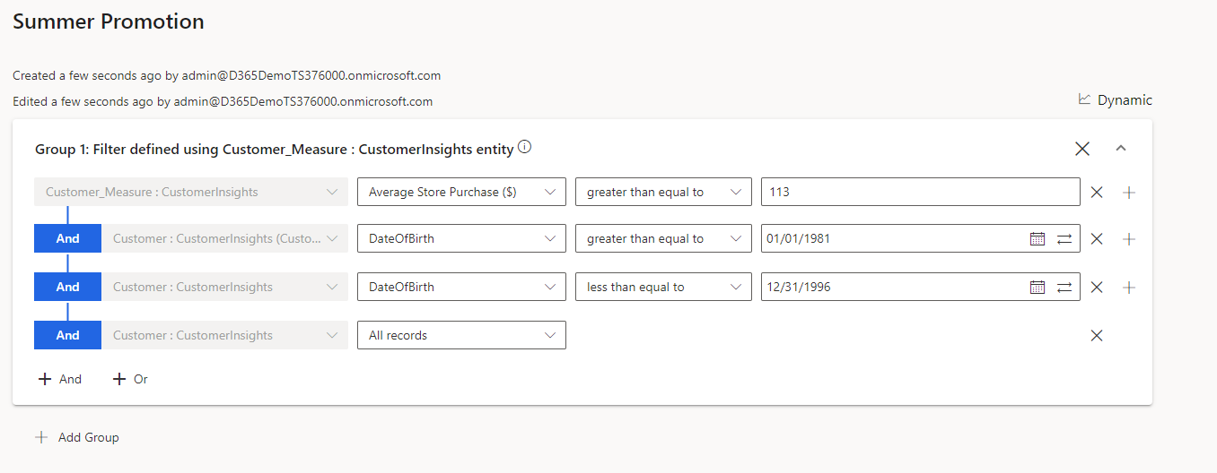

1. Click **Save** and then click **Activate**

## Task 4 – Review Segments

1. Wait for all your segments to successfully run then Navigate to the Customer Insights Home Page. You should see your segments displayed. **Note:** Your numbers may be slightly different if the underlying data has changed since the creation of this document.

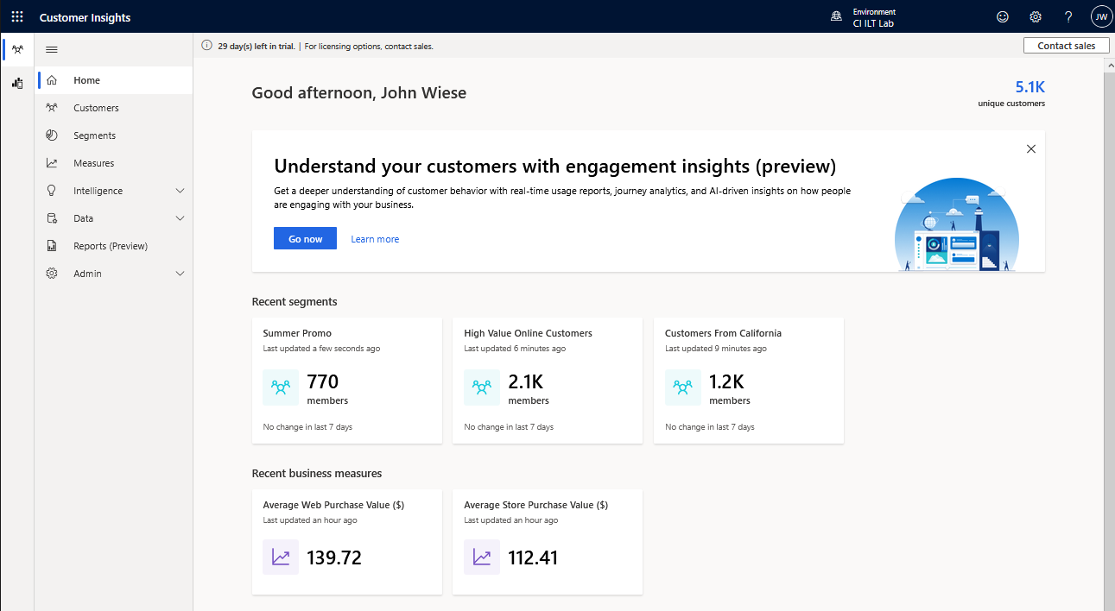

1. Click on one of your segments. You should see that you’re presented with a preview of the customers included within your segment, as well a timeline highlighting the segment size. This will display increases and decreases in the number of segment members as data changes over time and the segment is rerun. 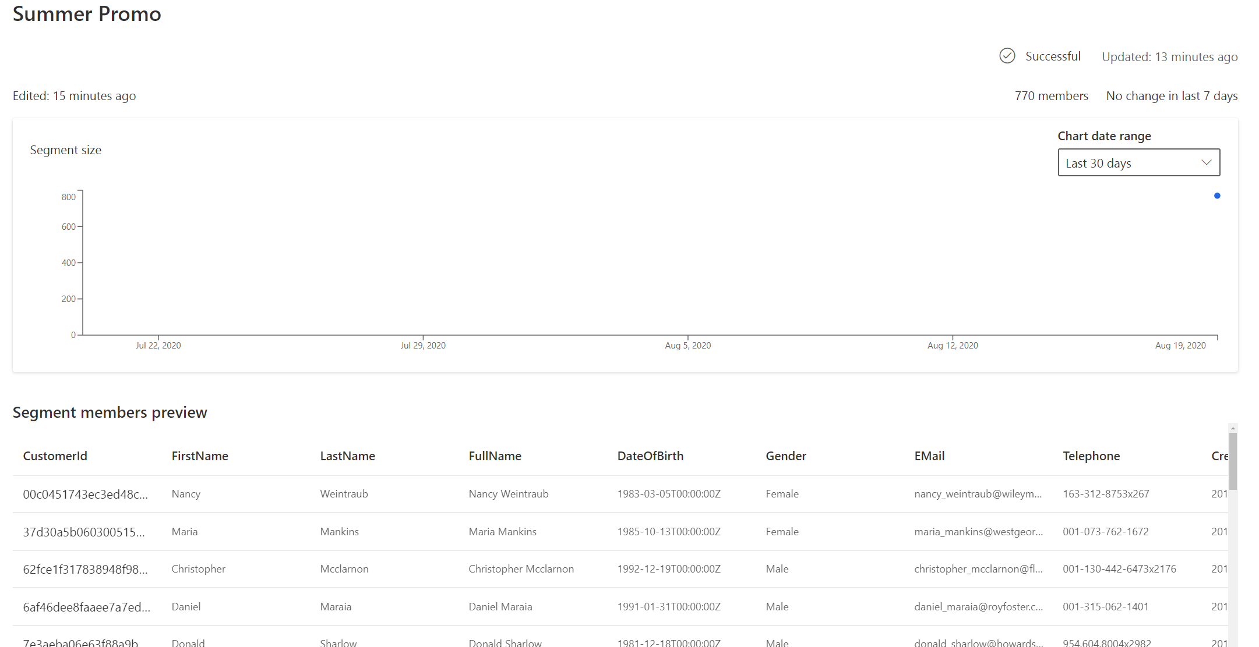
2. Now that you have created your segments you are ready to start acting upon your data. You can select the segment and click **Download** on the top for use in 3rd party software, or you can setup an Export Destination. Segments created within Customer Insights can be made available to other parts of the PowerPlatform, Dynamics 365 Marketing or external applications.

To do this you would go under **Admin -> Export Destinations** in the left side menu. Here you can setup and Export destination for **Dynamics 365 for Sales**,  **Dynamics 365 for Marketing**, **Azure Blob Storage** and several business applications or tools allowing you to use the segments to execute a Marketing Campaign. We will work through this in a different module.

## Task 5 – Apply Segment Insights

Let’s try to find out common customers that belong to both **Customers from California** and **High Value Online Customers** segments and also what differentiates both of these segments in terms of **Reward points** and **LifetimeSpend.**

1. Click on **Segments** in the left menu, click on **Insights** tab and click on **New** on the top**.**
2. You will now see two options as below:

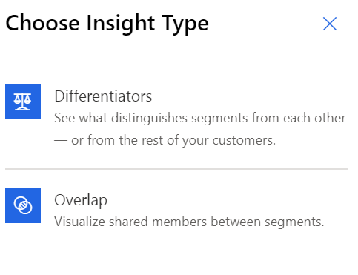

1. Let’s create using Differentiators first to see what distinguishes both of these segments. Click on **Differentiators.**
2. Choose **High Value Online Customers** as primary segment and hit **Next** and choose **Customers from California** as another segment and hit **Next.**
3. Now choose **Reward points** under Attributes and **LifetimeSpend** under Measures to see how the above segments differ from each other with respect to **Reward points** and **LifetimeSpend.**
4. Click **Next** and name your insight **High Value Online vs Customers from California** with an Output entity name of **HighValueOnlinevsCustomersfromCalifornia** and click **Save.**
5. After the run is successful, you can click on the created insight to see a screen like below. Click on the Attributes or Measures tabs to see how the segments differ from each other with respect to them. Observe the **Difference score** which signifies the degree of difference. The higher the score the more different they are. *You may need to refresh the browser window to see the results.*

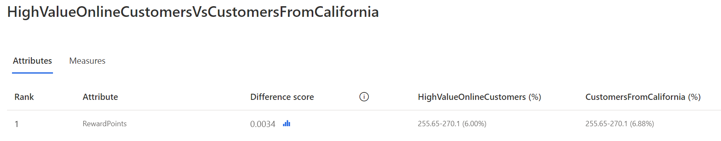

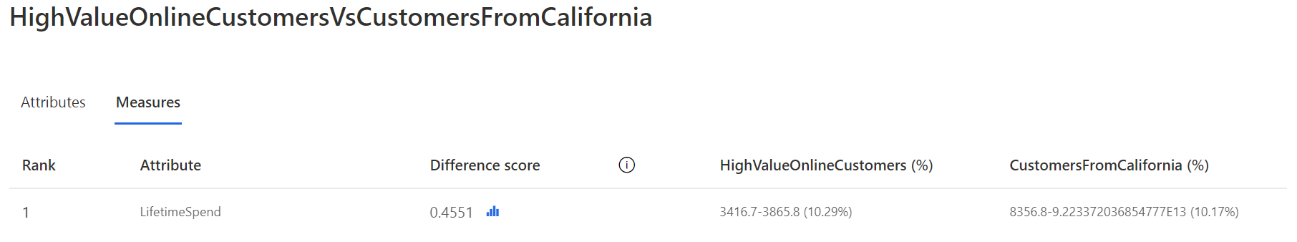

1. Click on each measure and attribute to see deeper insights like below

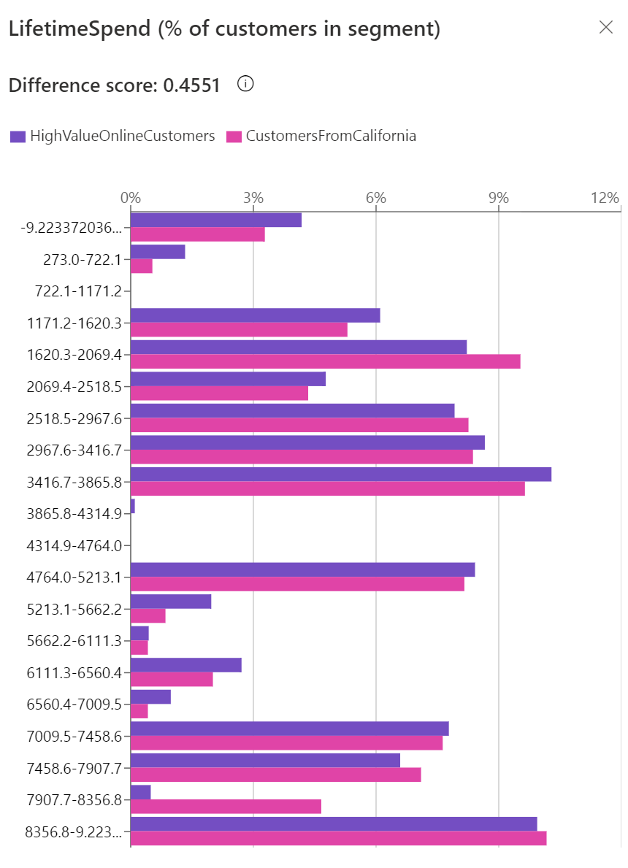

1. We have successfully created segment insights using **Differentiators.** Now let’s create using **Overlap**
2. Make sure you are still in **Insights** tab and click on **New** on the top left and now choose **Overlap.**
3. Select both **High Value Online Customers** and **Customers from California** segments to find out their shared customers.
4. Click **Next.**
5. Here as an optional step, you can also choose attributes to compare the segments just as we did with the **Differentiators.** You can simply hit **Next** without choosing anything**.**
6. Name your insight as **High Value Online Overlapped with California Customers** and set the Output entity name as **HighValueOnlineOverlappedwithCaliforniaCustomers**  then click **Save.**
7. After the run is successful, you can click on the created insight to see the screen like below detailing the total and percentage of shared customers between the two segments.

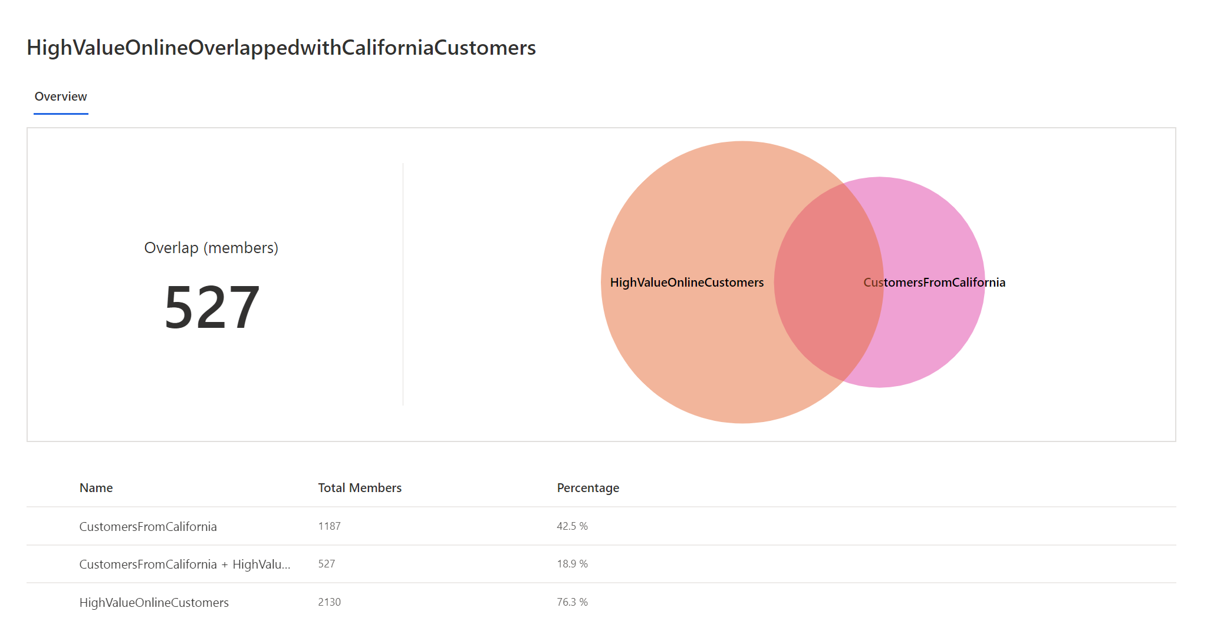

## Task 6 – Segment Expansion

Segment Expansion can be used to find similar customers to your segment customer base using Artificial Intelligence.

Earlier we created a segment called **Summer Promotion** which has millennial customers with higher than average instore purchase. Now, let us expand that segment and find customers that are similar to them for us to market our newly launched Cold Brew Coffee.

1. Click on **Segments** on the left menu and choose the **Summer Promotion** segment. It becomes our source segment.
2. Click on the three dots and choose **Find similar customers**.

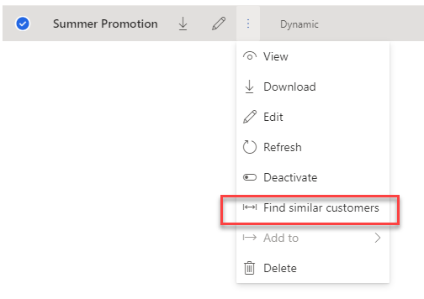

1. Name your segment **Summer Promotion Expansion**
2. Click on **Add fields** in the next step to select attributes and measures that are used to find similar customers. We’ll target customers with similar average instore purchase and location. So, we will choose **PostCode** and **AverageStorePurchase** and click **Apply.**

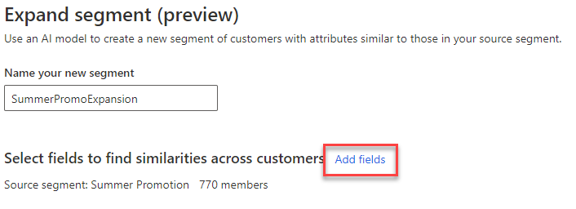 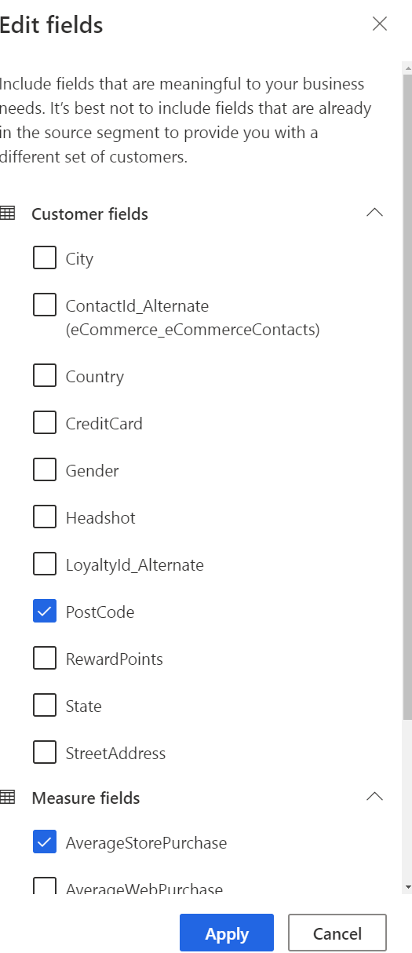

1. Next you must choose who to consider, either all customers except from source segment or customers from a different segment. If different segment is selected, then we must choose which segment it is. For now, select **All customers except source segment.**
2. Now the maximum number of customers to include must be selected. By default, 20% of the customers is selected which can be altered. Let us stick with 20%.
3. If you like to include members from source segment as well then check the note at the bottom else leave it unchecked.
4. Hit **Run.**

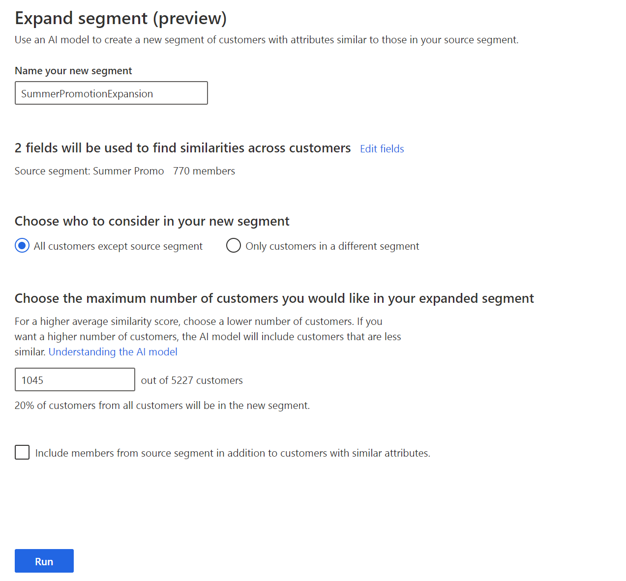

1. After the run, you can see a new segment being created and click on it to find the similarity scores which range from 0.55 to 1(0.85-1 -> Very similar, 0.7-0.85 -> Similar, 0.55-0.7 -> Somewhat similar) and check the similar customer records.

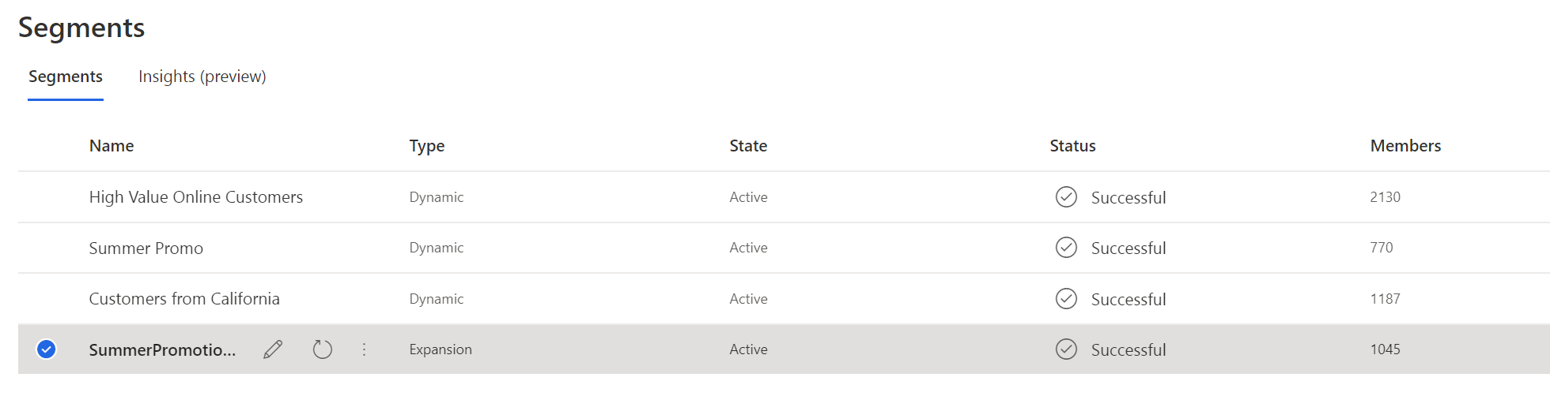

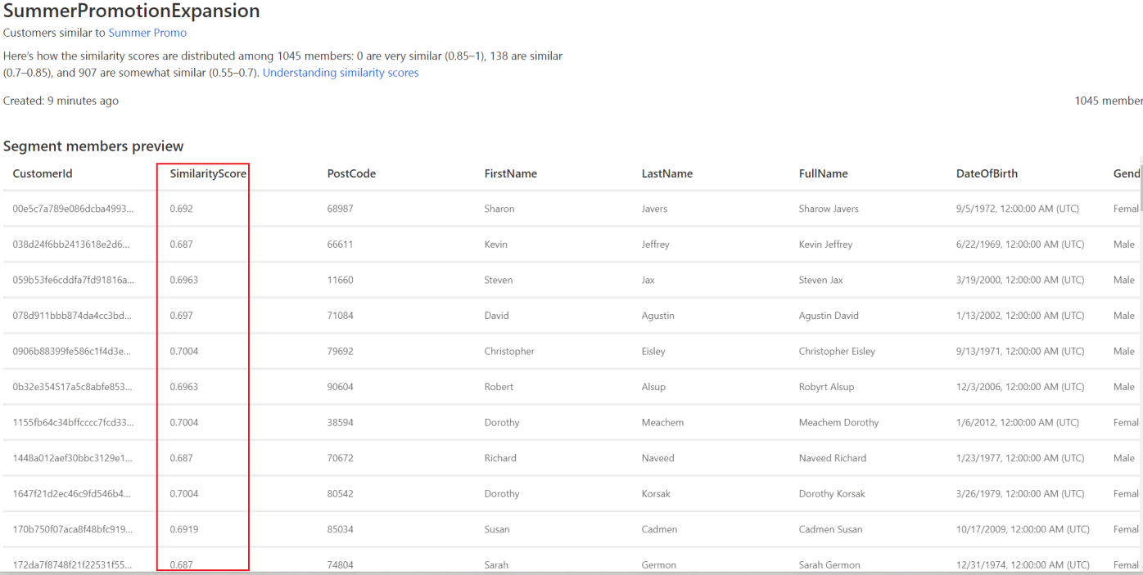

## Optional – Suggested Segments

Use Suggested Segments to discover interesting segments based on a customer attribute or measure of interest

### Discover interesting segments based on a numeric customer attribute or measure of interest

1. Under the Segments section, click on the **Suggestions (preview)** tab.

Graphical user interface, application


1. Click on **Get Suggestions** to begin the configuration experience.
2. We will choose **Improve a measure/metric**
3. Next, you need to select the target attribute i.e., a customer attribute or measure of interest, for which you want to discover segment suggestions. We will select the previously created measure **LifetimeSpend** as the target attribute.
4. Next, you will select the attributes that might influence the target attribute (LifetimeSpend) so that the AI model can find interesting patterns between the influencing attributes and the target attribute and suggest segments based on those patterns. We will select **Email Subscriber, Income, Loyalty Tier, Occupation** and **State** as the influencing attributes.

**Note:** In case you do not know which attributes to select, it is advised to select many attributes so that the model can analyze, and surface segment suggestions based on the underlying patterns it uncovers. However, if you want to see how certain attributes influence “LifetimeSpend”, you can choose only those as well.

1. Click on **Run**. The AI model will start finding patterns between the selected influencing attributes and the target attribute to surface segment suggestions. Please wait for a few minutes for the model to finish its analysis.
2. Once the model has finished running and if it is able to uncover patterns between the influencing attributes and the target attribute, segment suggestions will be displayed under the **Suggestions (preview)** tab.   
      
   Graphical user interface, application

   Description automatically generated  
   Since we’ve chosen a numeric attribute as the target attribute, segment suggestions include those where the average value of the chosen target attribute (LifetimeSpend) is ***significantly higher or lower that the average*** LifetimeSpend value across all customers. We will also explore a scenario where a categorical attribute (Eg – Customer Satisfaction: low/medium/high) is chosen as the target attribute in the next task.   
      
   Each segment suggestion card denotes how the average LifetimeSpend in that segment compares to the overall average. The number of customers in the suggestion as well as the rules learned (i.e. common traits of customers in the segment) are also highlighted.

E.g. – in the above suggestion, **LifetimeSpend is 20% above average** i.e. the customers in this segment have historically spent much more as compared to others. There are **585 members** in this segment and they have **Income > 97k** and a **high Loyalty Tier.**

1. You can click on any suggestion to see more details in the side panel. We will click on the **See suggestion** link for the suggestion that says **LifetimeSpend is 15% below average**. In the side panel, you will see the following:

* 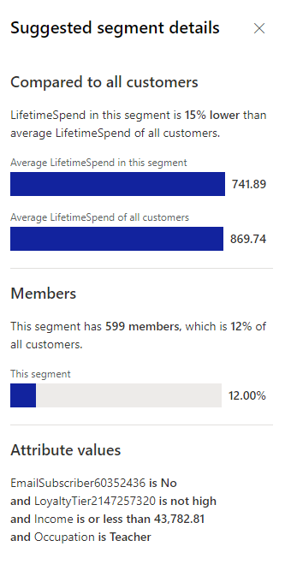Comparison of average LifetimeSpend of customers in this segment compared to all the customers
* Number of customers in the segment and its proportion as compared to the entire customer base
* The attribute values i.e., the rules that the model learned based on the selected influencing attributes.

In this case, customers in this segment have an average LifetimeSpend of 741.89 as compared to average LifetimeSpend of 869.74 across all customers. There are 599 members in this segment which is 12% of the entire customer base. These customers are ***not Email Subscribers, have an income less than 44k, do not belong to the high loyalty tier and are teachers***. This information can then be used to target customers in this segment with personalized messaging to drive more revenue and corresponding business goals.

In a similar fashion, you can see details of other segment suggestions that you are interested in.

1. You can then save the segment by clicking on **Save as segment** in the side panel.   
   Name the segment and Output entity name as follows and click on **Save**.   
   Graphical user interface, application

   Description automatically generated
2. The saved segment can then be viewed under the **All segments** tab and it can be used for downstream processes like any other dynamic segment. If you wish to look at the rules that the model learned after saving a segment, you can do so by clicking on **Edit** in the **All segments** tab.   
    A screenshot of a computer

   Description automatically generated with medium confidence
3. We have successfully found **segment suggestions** based on a measure of interest (**LifetimeSpend**). We also saved a segment which can then be utilized for downstream processes like any other dynamic segment.

### Discover interesting segments based on a categorical customer attribute or measure of interest

1. Under the Suggestions tab, click on **Find new suggestions** in the top menuto explore segment suggestions based on a different customer attribute or measure. Note that, this will replace the existing set of suggestions.
2. We again will choose **Improve a measure/metric**
3. Select **CustomerSatisfaction** as the target attribute of interest. Customer Satisfaction is a categorical attribute with 3 categories (low/medium/high) and we’d like to find segment suggestions based on this attribute. Then click **Next**.

1. Next, select **Email Subscriber, Income, Loyalty Tier, Occupation, RewardsPoints** and **State** as the influencing attributes.

1. Click on **Run**. The AI model will start finding patterns between the selected influencing attributes and the target attribute to surface segment suggestions. Please wait for a few minutes for the model to finish its analysis.
2. Once the model has finished running, segment suggestions will be displayed under the **Suggestions (preview)** tab.

Since the target attribute is categorical, the AI model tries to find patterns/common traits of customers belonging to a particular category of the target attribute and surfaces segment suggestions. Since Customer Satisfaction has 3 different categories – **low, medium and high** – the AI model will try to find segments of customers that possess the same traits and a significant portion of them belong to a particular category (i.e. either low, medium or high).

**Note:** While only a few tiles are shown initially, you can click the **See More** link to see more suggestions that were found.

1. You can click on any suggestion to see segment details in the side panel. We will click on the suggestion that says **83% of customers in this suggestion have CustomerSatisfaction = low**. In the side panel, you will see the following:

* 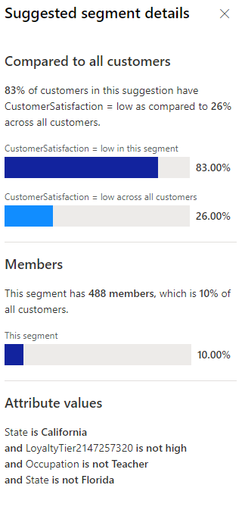Comparison of percentage of customers in this segment that have CustomerSatisfaction = Low as compared to percentage of all customers that have CustomerSatisfaction = Low
* Number of customers in the segment and its proportion as compared to the entire customer base
* The attribute values i.e. the rules that the model learned based on the selected influencing attributes.

In this case, **83%** of customers in this segment have CustomerSatisfaction = low as compared to **26%** among all customers. There are **488** members in this segment which is **10%** of the entire customer base. These customers are ***live in California, do not belong to the high loyalty tier, are not Teachers and do not live in Florida***. This helps provide insight that 94% of customers having the above-mentioned traits have a low customer satisfaction. This information can then be used to target customers in this segment with personalized messaging and/or customer service to help improve their customer satisfaction and in turn address corresponding business goals.

In a similar fashion, you can see details of other segment suggestions that you are interested in.

1. You can then save the segment by clicking on **Save as segment** in the side panel.   
   The segment can then be viewed under the **All segments** tab and it can be used for downstream processes like any other dynamic segment. If you wish to look at the rules that the model learned after saving a segment, you can do so by clicking on **Edit** in the **All segments** tab.
2. We have successfully found **segment suggestions** based on a categorical attribute of interest (**CustomerSatisfaction**). We also saved a segment which can then be utilized for downstream processes like any other dynamic segment.

# Exercise 2 – Customer Search

In Lab 4A we completed the **Map** 🡪 **Match 🡪 Merge** process to result in a unified customer profile.  
  
In this lab we will setup Search and Filter criteria to enable Customer Insights users to search for unified customer profiles so that you can quickly pull information on a specific customer or group of customers.

## Task 1 – Configure the Search Columns and Filter Index

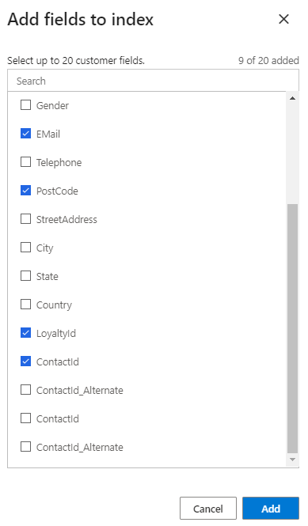

1. Click **Customers** in the left menu bar
2. Click **Search & Filter Index**
3. Few customer search specific fields are already added by default and you can add more by clicking **Add** on the right-hand side

Make sure **CustomerId**, **FirstName, LastName, FullName, DateOfBirth, Email, PostCode, Headshot, ContactId, LoyaltyId,** are selected.

1. These selected attributes will be indexed and used when searching for a Customer profile.

You can also apply string filters like sort attributes from A-Z or Z-A or highest to lowest frequency. To do that, click **Add filter** across the selected search attributes.

1. Once after you review, click **Save** and **Run**

## Task 2 – Search for a Customer Record

1. Click **Customers** in the left menu bar. You should now be presented with a set of customer cards, representing the Unified Profiles. You can expand cards to see more about the customer or sort the cards with various fields by clicking on **Expand cards** and **Sort** options on the top.

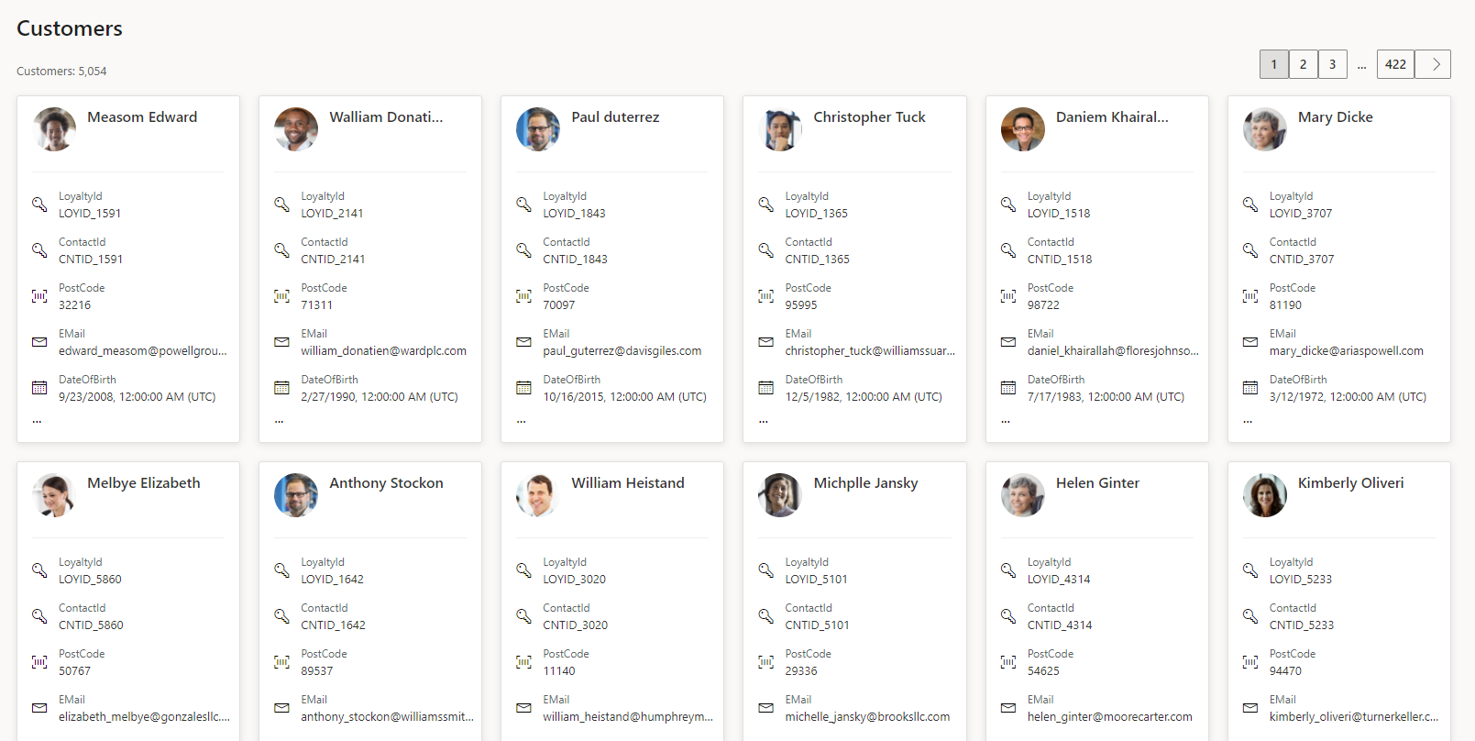

1. You can use the search bar to search for **Text attributes** relating to unified customer profiles. E.g. Searching ‘**24502**’ will search against all text attributes and return matches and partial matches.

Use the search bar to answer the following questions.

* What is Brian Gobble’s Date of Birth?   
  (Search with value ‘Brian Gobble’)
* Which customer has Loyalty Card ID LOYID_5707?   
  (Search with value ‘LOYID_5707’)

Which customer has a postcode of 24502?   
(Search ‘24502’)

# Exercise 3 – Setting up Activities

The Activities capability helps consolidate customer activities from various data sources. This creates a customer timeline view of all customer interactions against your unified customer profile. Business analysts can configure activities to be displayed on a customer dashboard with a timeline view, which can be embedded in business applications.

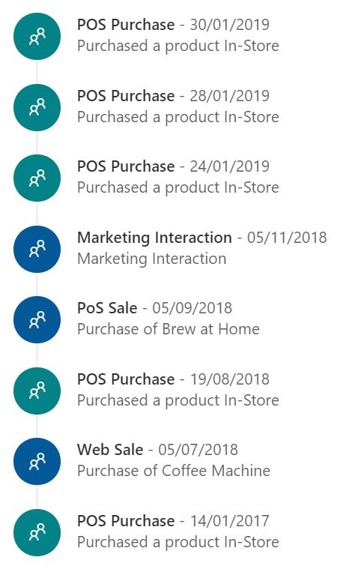Interactions are any customer touch points – these could include purchases, customer service cases, emails, phone calls, branch visits, web, social activity. In other scenarios interactions could also be data gathered from connected devices, withdrawals or deposits in banking, entry/exist of a premises or area etc.

## Task 1 – Add an activity for eCommerce Purchases

1. Within Customer Insights, Expand **Data ->** **Activities** on the left menu and click **Add Activity**
2. On the **Activity data** screen set the following values:

* Activity name: **OnlinePurchase**
* Entity: **Purchases : eCommerce**
* Primary Key: **PurchaseId**

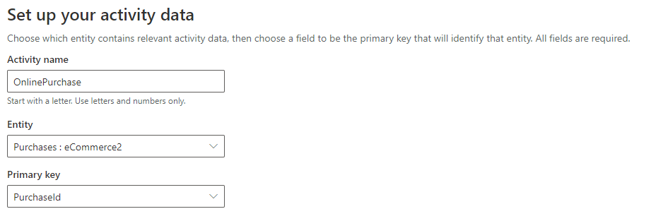

1. Click **Next**.On the **Realtionships** screen click Add relationship

1. In the **Add relationship path** pop-up set the following values:

* Foreign key: **ContactId**
* 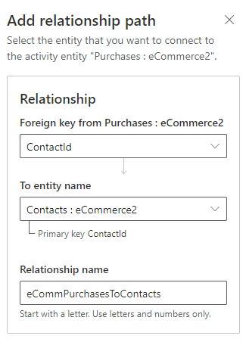To entity name: **Contacts : eCommerce**
* Relationshiop name: **eCommPurchasesToContacts**

1. Click **Apply** to close the pop-up
2. Click **Next**
3. On the **Unify your customer activity data** screen set the following values:

* Event activity: **AcitivtyTypeDisplay**
* Timestamp: **PurchasedOn**
* Additional detail: **Subject**
* Icon: Graphical UI

1. Click **Next**
2. One the **Set activity type** screen set the type to **Create New** and then enter **OnlinePurchase** for the Activity Type Name.

1. Click **Next**, review your entries then click **Save activity**

## Task 2 – Add an activity for PoSPurchases

1. Click **Add Activity**
2. On the **Activity data** screen set the following values:

* Activity name: **PoSPurchase**
* Entity: **Purchases : PoS**
* Primary Key: **PurchaseId**

1. Click **Next**. On the **Realtionships** screen click Add relationship

1. In the **Add relationship path** pop-up set the following values:

* 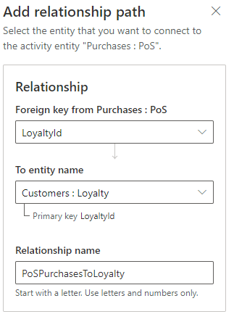Foreign key: **LoyaltyId**
* To entity name: **Customers : Loyalty**
* Relationshiop name: **PoSPurchasesToLoyalty**

1. Click **Apply** to close the pop-up
2. Click **Next**
3. On the **Unify your customer activity data** screen set the following values:

* Event activity: **AcitivtyTypeDisplay**
* Timestamp: **PurchasedOn**
* Additional detail: **Subject**
* Icon: Graphical UI

1. Click **Next**
2. One the **Set activity type** screen set the type to **Create New** and then enter **PoSPurchase** for the Activity Type Name.

1. Click **Next**, review your entries then click **Save activity**

## Task 3 – Add an activity for Website Reviews

1. Click **Add Activity**
2. On the **Activity data** screen set the following values:

* Activity name: **WebsiteReview**
* Entity: **Reviews : Website**
* Primary Key: **ReviewId**

1. Click **Next**. On the **Realtionships** screen click Add relationship

1. In the **Add relationship path** pop-up set the following values:

* 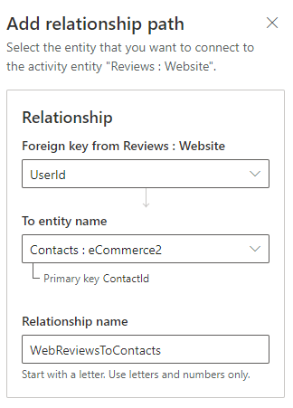Foreign key: **UserId**
* To entity name: **Contacts : eCommerce**
* Relationshiop name: **WebReviewsToContacts**

1. Click **Apply** to close the pop-up
2. Click **Next**
3. On the **Unify your customer activity data** screen set the following values:

* Event activity: **AcitivtyTypeDisplay**
* Timestamp: **ReviewDate**
* Additional detail: **ReviewText**
* Icon: Graphical UI

1. Click **Next**
2. One the **Set activity type** screen set the type to **Create New** and then enter **WebsiteReview** for the Activity Type Name.

1. Click **Next**, review your entries then click **Save activity**

## Task 4 – Confirm the Activities

Click **Run** on the top to run the configured activities. Once they have completed click on **Customers** in the left-hand menu

1. Search for **Abbie Moss**
2. You should now see activities listed for **Abbie** on the timeline. Try using the Filter to view only specific activities.

# Exercise 4 – Enriching the Data

When it comes to enriching your data, you will need to decide on the Brands and Categories that apply to your business. You will be able to find many of the relevant brands and categories in the list from the Microsoft Graph to choose from. In our case we will look for specific coffee companies for our brands, and beverage related categories to enrich our data with.

Think of enrichment as a way to say, “for all of my customers, show me their likely affinity towards each of these brands and interest in these categories based on the fields I map”. Then for each customer we go out and look for all the people in the graph that are similar age, location and/or gender and calculate their brand affinity and interests to enrich your data.

You can also choose third party applications to enrich your data like Leadspace, Experian etc. but make sure you have right privileges to access.

For this lab, we will configure enrichment using Microsoft Graph.

## 

## Task 1 – Adding Brand Affinity

1. Navigate to **Data -> Enrichment**
2. Click the **Enrich my data** button on the **Brands** tile

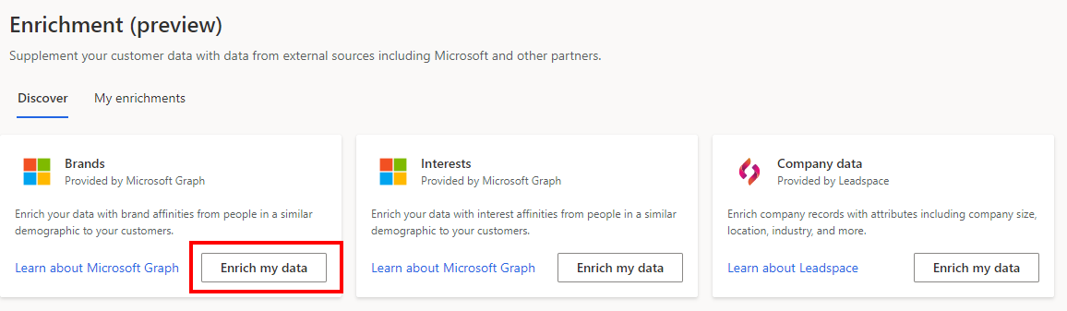

1. Select **Choose an industry**. Review the list of categories that are presented in the **Industry** dropdown. Note that there doesn’t appear to be anything specific to our industry so we will not go this route. We could possibly use **Retail Brands** but that is simply not specific enough for our use case.
2. Select **Choose your own.**
3. In the **Brands** box enter these brands:
   * Peet’s Coffee
   * Blue Bottle Coffee
   * Caribou Coffee
   * Dunkin Donuts
   * Starbucks

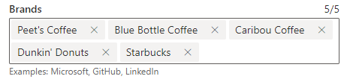

1. Click **Next**
2. On the **Enrichment preferences** screen leave the brand affinity levelat **Medium** and **set** the match precision to **Exact and aggregate**
3. Click **Next**
4. On the **Add data set** screen choose **Customer** from the **Profiles** section in the dropdown, then click **Next**.

1. On the **Data Mapping** screen we will choose the fields to map our data with the data from the graph. We can map both demographic as well as location information. At a minimum you must map a country/region. We will map more attributes to get a more refined result.

The system will pre-fill the entries when it can find a likely match. You can overide the entry by clicking the dropdown and selecting a different field. Here are the settings we will use:

* Date of Birth: **DateOfBirth**
* Gender: **Gender**
* Country/Region: **Country**
* City: **City**
* State/Province: **State**

1. Click **Next** and review your entries
2. Name your enrichment **BrandEnrichment**
3. Click **Save enrichment** and then **Done**

## Task 2 – Adding Interests Affinity

1. Navigate to **Data -> Enrichment -> Discover**
2. Click the **Enrich my data** button on the **Interests** tile

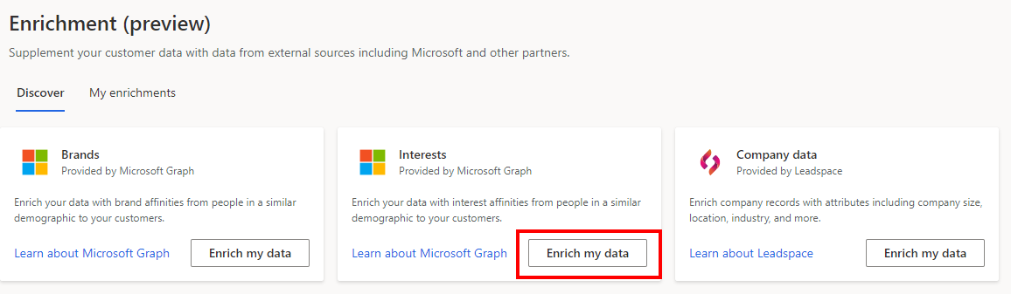

1. In the **Interest** box enter these interests:
   * Bottled Water & Water Delivery
   * Coffee
   * Tea
   * Sport Drinks
   * Alcoholic Beverages

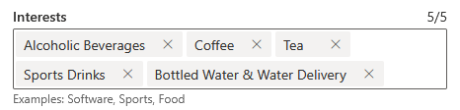

1. Click **Next**
2. On the **Enrichment preferences** screen leave the brand affinity levelat **Medium** and **set** the match precision to **Exact and aggregate**
3. Click **Next**
4. On the **Add data set** screen choose **Customer** from the **Profiles** section in the dropdown, then click **Next**.

1. On the **Data Mapping** screen we will choose the fields to map our data with the data from the graph. We can map both demographic as well as location information. At a minimum you must map a country/region. We will map more attributes to get a more refined result. The system will pre-fill the entries when it can find a likely match. You can overide the entry by clicking the dropdown and selecting a different field. Here are the settings we will use:

* Date of Birth: **DateOfBirth**
* Gender: **Gender**
* Country/Region: **Country**
* City: **City**
* State/Province: **State**

1. Click **Next** and review your entries
2. Name your enrichment **InterestEnrichment**
3. Click **Save enrichment** and then **Done**
4. Next, we need to run the enrichments we just created. If you are not the **My enrichments** tab on the **Enrichments** page click on **Data -> Enrichment** in the left hand menu, then click on the **My enrichments** tab. You should see the two enrichments we just configured.

1. Click on **Run all** in the top menu and let the enrichments run

## Task 3 – Review the Enriched Data

Once enrichment has finished running, it may take a bit, you can then look at what was created.

1. The first thing you will see is the number of profiles that were enriched with data.

1. Now, we’ll look at one of the two entities that were created to hold the enrichment data. Click on **Data -> Entities** and then under **Enrichment** click on either the **BrandAffinityFromMicrosoft** or **InterestAffinityFromMicrosoft** entity. This is where we store the enrichment data.

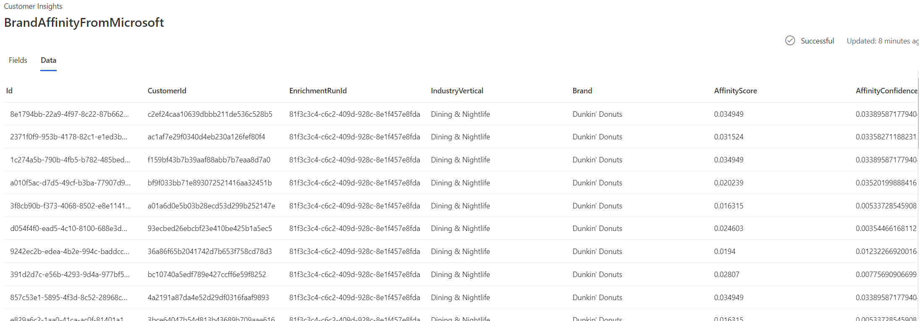

Here you will see the **IndustryVertical** a brand is listed in, the affinity score for a customer profile and affinity confidence as well as other information depending on which fields you mapped.

From this view you can also download a CSV of the data to work with offline.

1. Now let’s look at what we see for a specific customer. On the **Customer** page pick a customer (we’ll use **Joseph Chestnut**). When you view the customer detail page you will see the enrichment that pertains to ‘people like’ that customer. This is based on the fields you chose to map when you configured the Enrichment, in our case: DateOfBirth, Gender, Geography.

